Rhythmic Gymnastics
Skulls (two)
Crown
Ball
Ribbon
Group programs
Jumping rope
Skirts (two per athlete)
Crown
Ball
Ribbon
Track
Street racing:
race
semi-endurance races
endurance races
relay races
Stipl
throwing sports
long jumps, high jumps, short jumps, triple jump
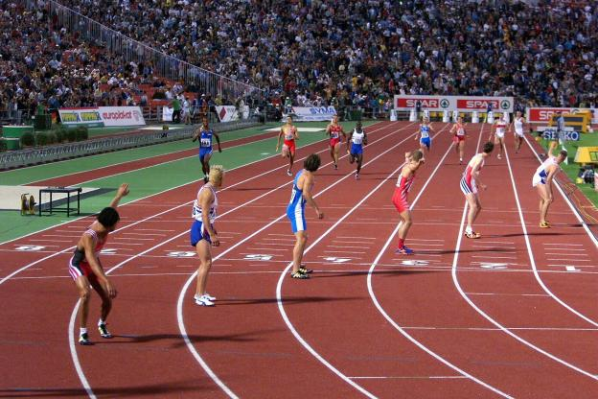

By Vivianna, Elpida and Christine

